- A polynomial ax+ a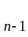 x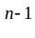+ … + a can be evaluated in a straightforward way by performing the indicated operations and using power function. An alternative method is to factor the polynomial according to the following formula, known as HORNER’S Rule:
(…( ( ax + a ) x + a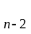) x + …+ a ) + a
(a). Write two program to evaluate polynomials by these two different methods.
(b). Please compare these two method.

- 由於長整數的有效位數只到 10 位 請設計一個程式能作有效位數到 40 位的整數相加，
相減，…。
EX: 4395490521770611790310760823760402
+ 256374183688815996882456477230188

4651864705459427787193217300990590

- Considering the problem of coloring a map with a set of four distinct colors, such that no two adjacent countries have the same color. The map to be colored is in the following figure:

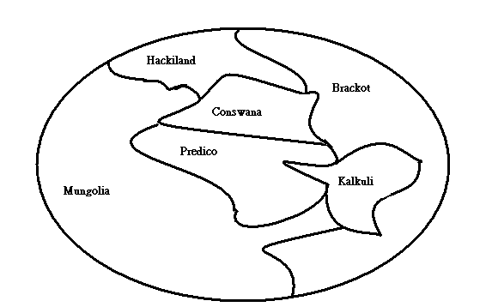

The four colors: Blue, Green, Red, and Yellow.
The six countries: Hackiland, Brackot, Conswana, Kalkuli, Predico, Mungolia.
Please write a program to list all possible color sets for the six countries
.
- Given a set of n＞＝1 elements, print out all possible permutations of this set.
- Write a program to input two binary data and output the sum, difference, and multiplication of the two binary numbers.

